Login to the website using the Members Only Link at the top of the page:

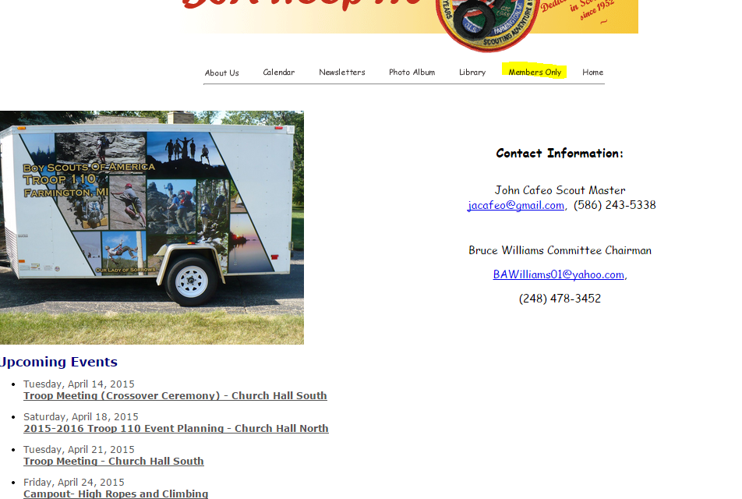
Login using the provide username:

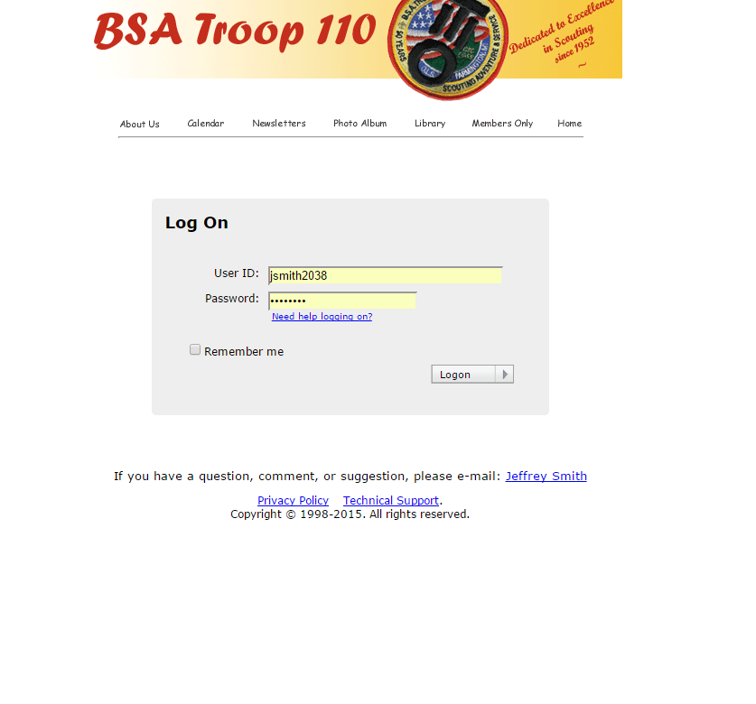

Next step is to select the event that you want to register for from the Troop Calendar:
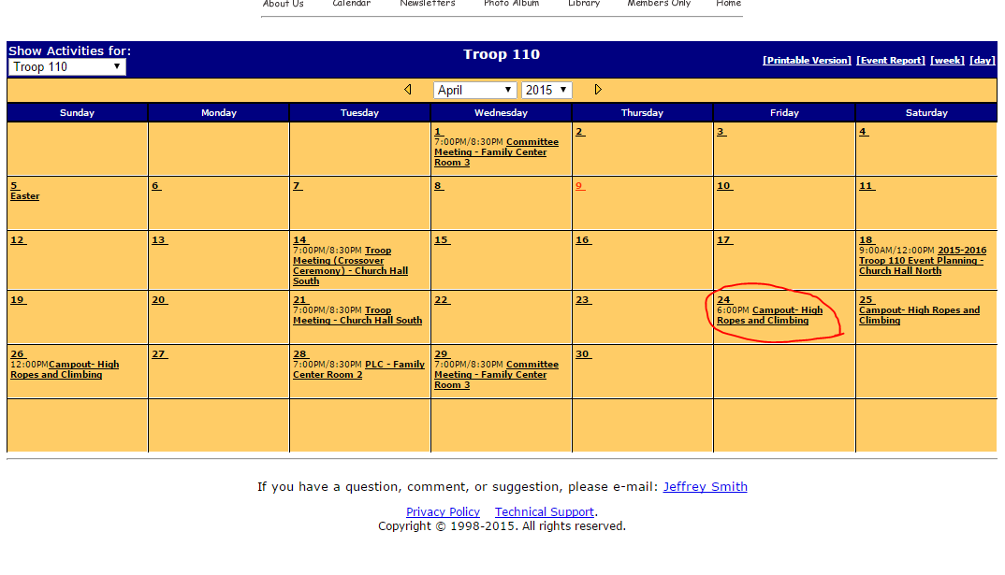

When you select the link on the event you will be brought to the event page.
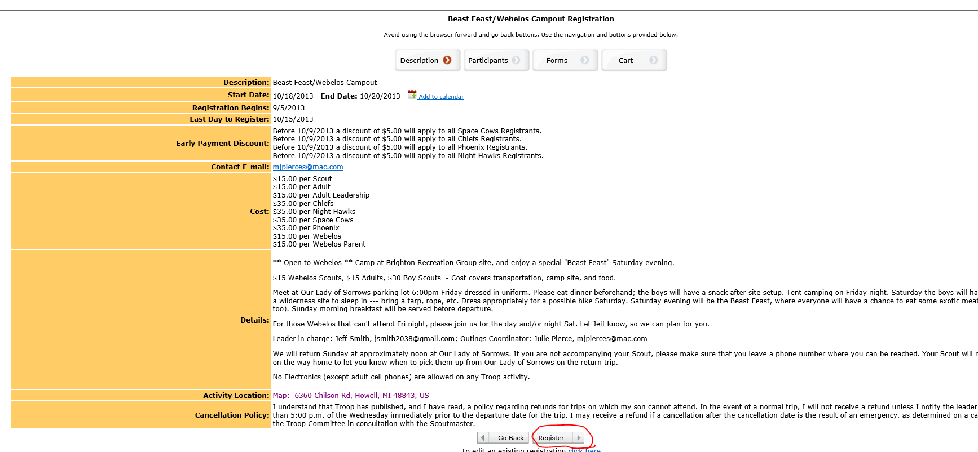

Select Add New Participant, or if the correct person is already under the Available Participant list in the right column, click the green plus next to the name.
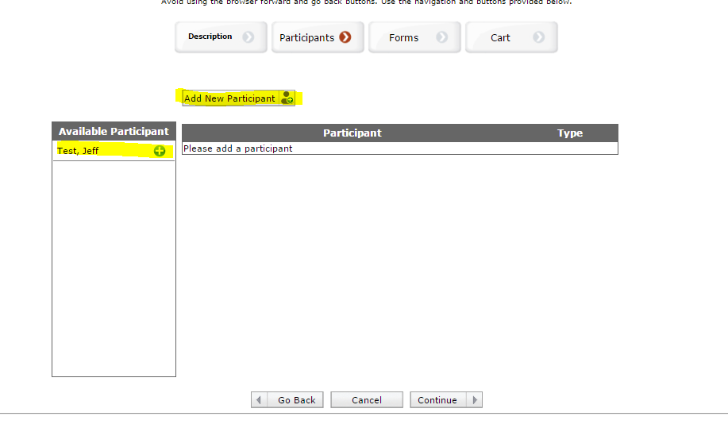
Select the Paticipant type and select add. You may need todo this step twice, once for Scout and once for any attending parent.
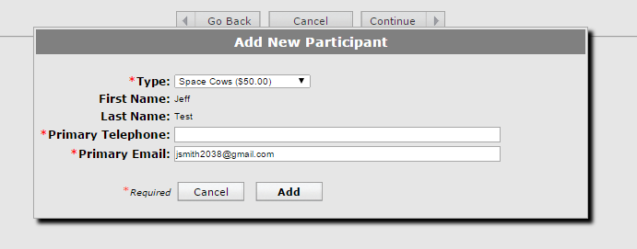
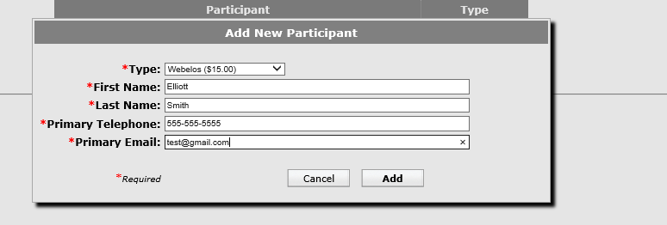
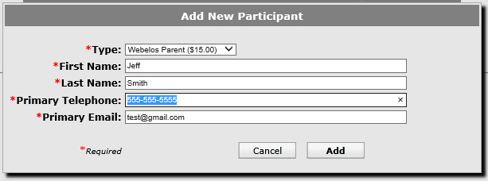

Once you have the attending entered, press Continue
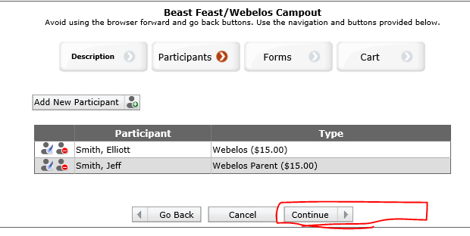
This is where it gets a little confusing. We have two web forms that we ask everyone to fill out. Fist select the default permission slip form.
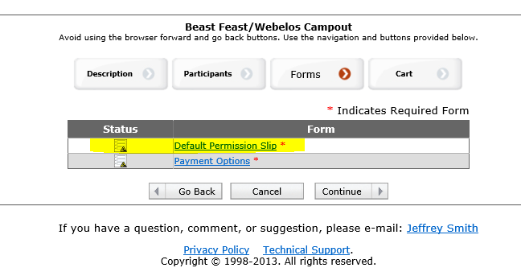
Just answer the questions and select continue
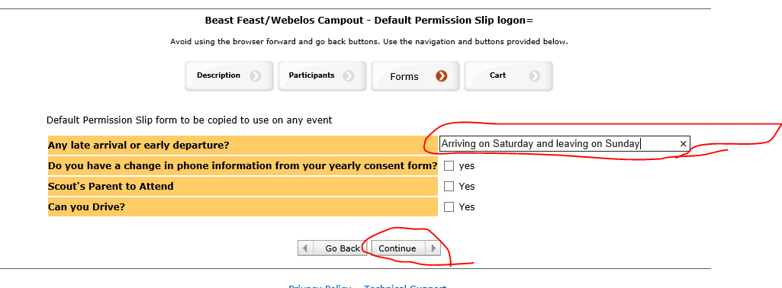
If you select yes on the do you have a change in phone information on the yearly consent form you will be given a new window to verify
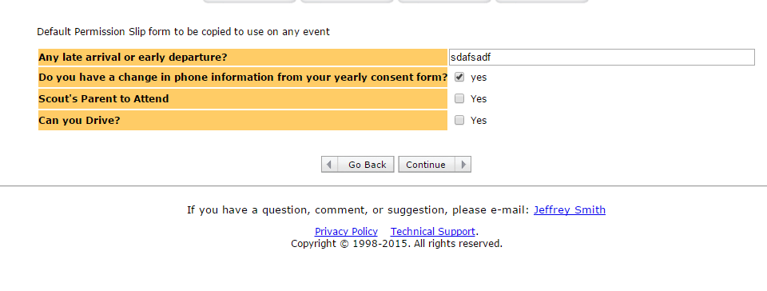
Just fill in the updated info and press continue
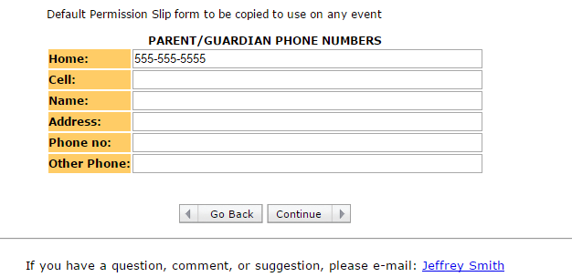

If you select the Scouts parent to attend, you will be prompted with a screen to answer questions on youth protection.
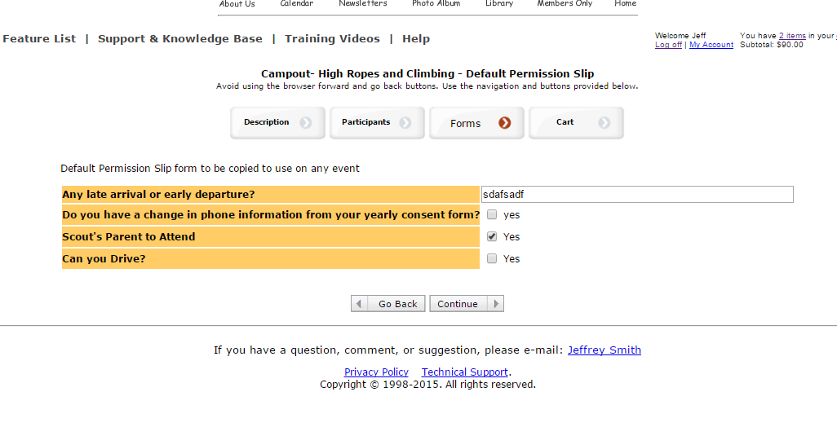

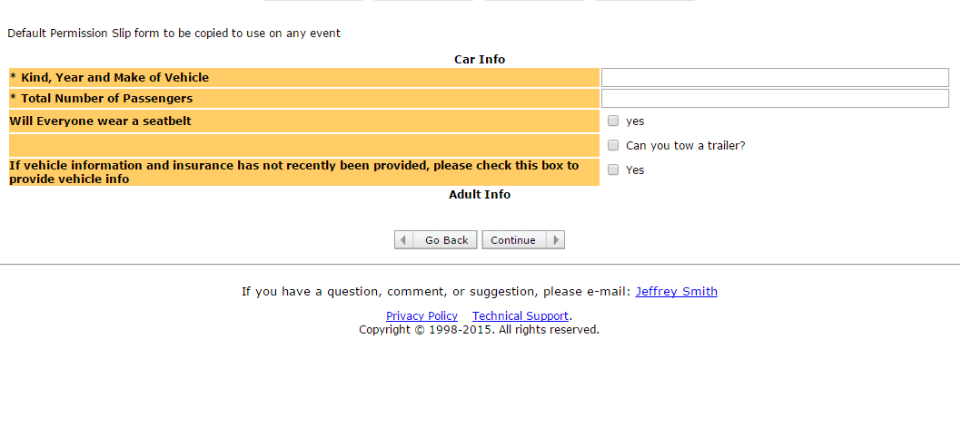

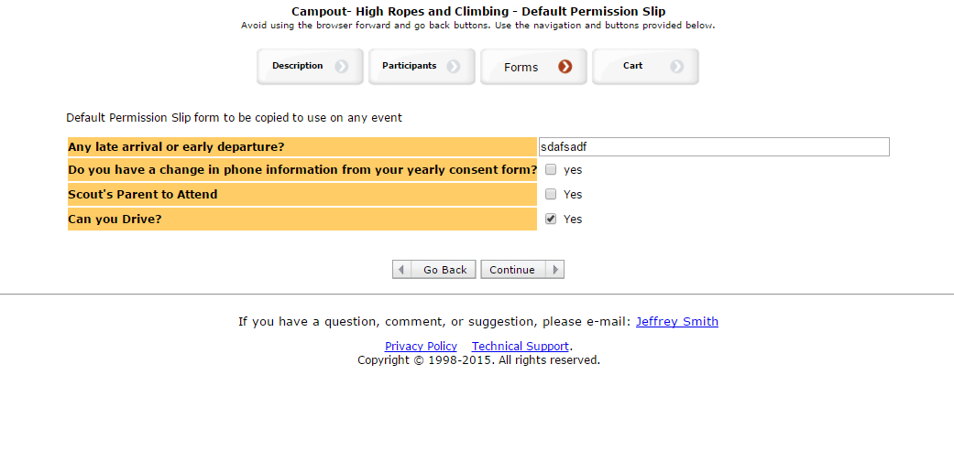
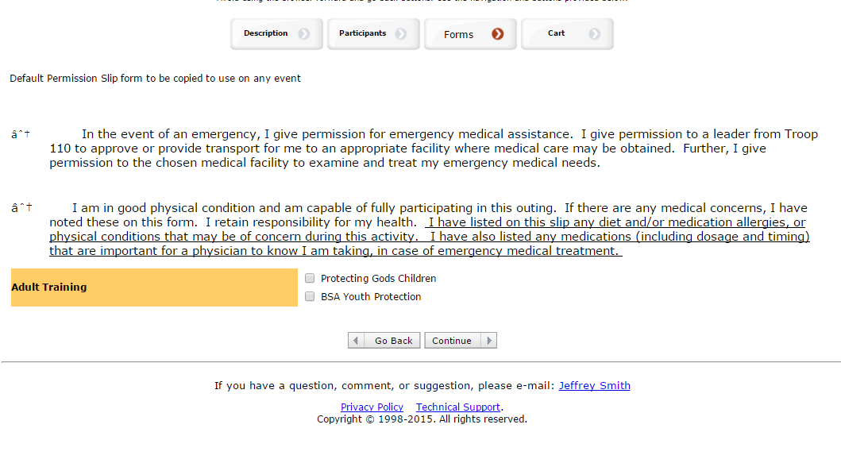
Fill in the requested info and select continue

If you select the Can you Drive checkbox you will be prompted for your auto info

Fill in the vehicle information and press continue. If you select that you have a change in Insurance you will be prompted for the info. 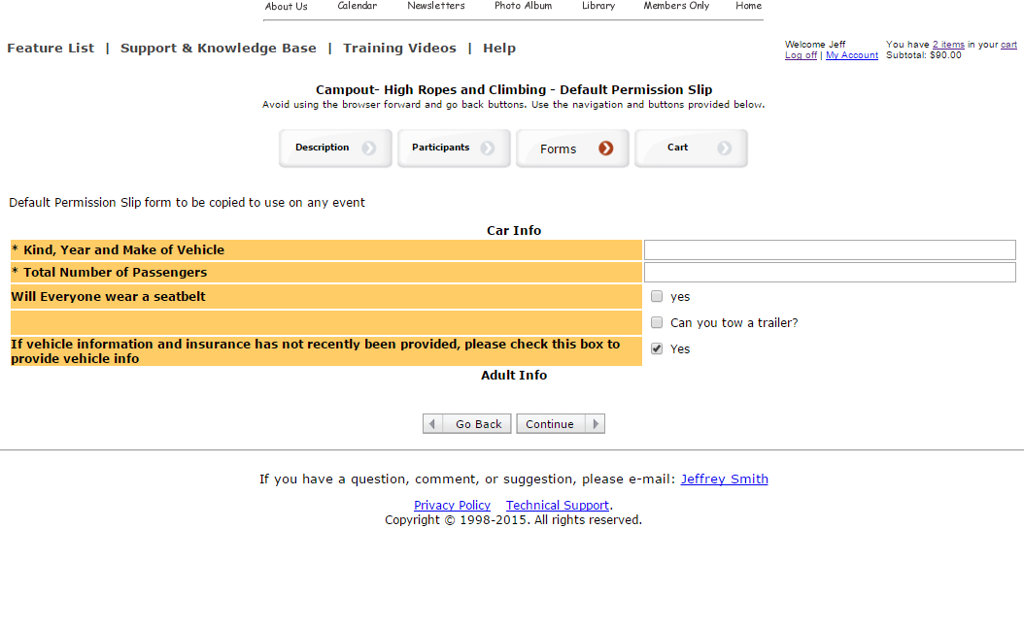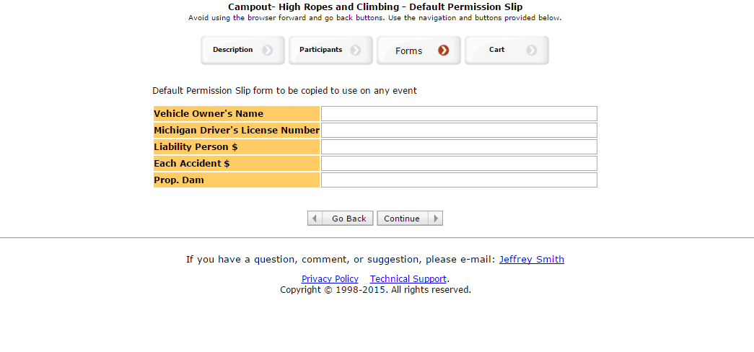

The default permission slip is complete
Select Payment Options. And let us know how you are paying.
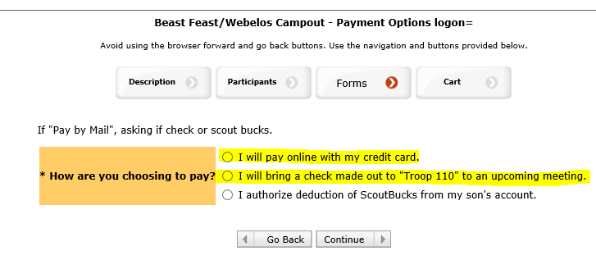
Your Screen should look like this and hit continue.
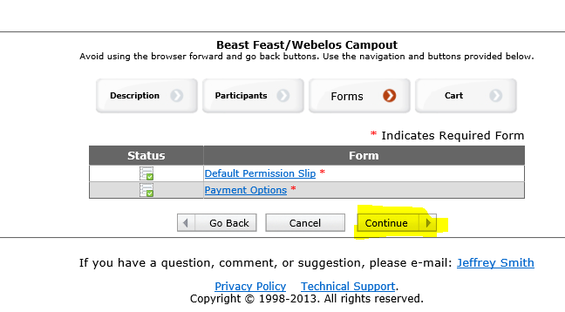
The checkout screen should appear, select checkout.
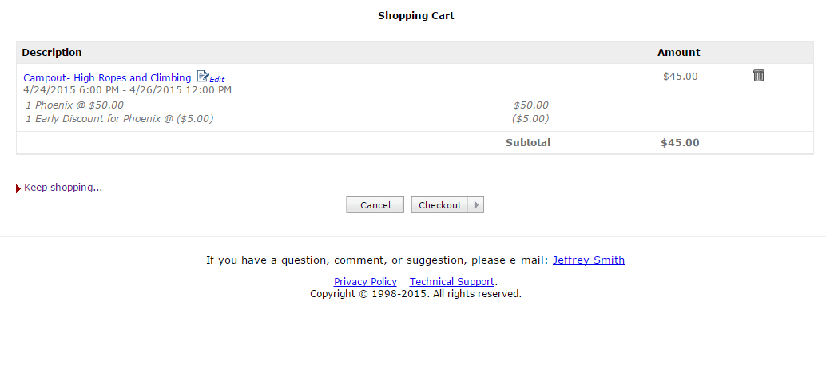

You can either mail us a check, pay by Credit Card or paypal
