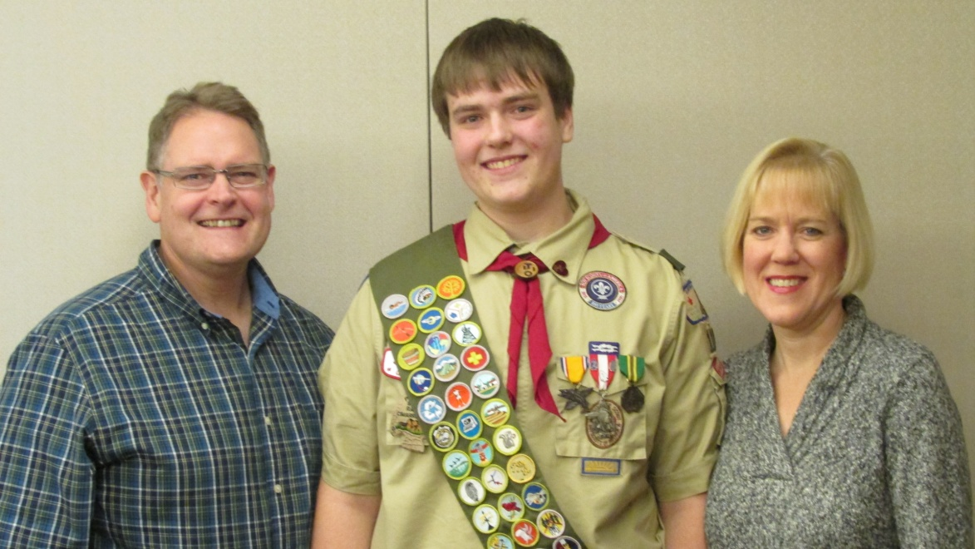

**Eagle Scout Court of Honor**

Troop 110

*Chartered through*

Our Lady of Sorrows

Ottawa District

Great Lakes Field Service Council

Michigan Crossroads Council

April 27, 2014

**Evan Jacob Murphy**

**Thank You**

*Thank you to all of the leaders, Scouts, teachers, family and friends that have helped make this day. Without your willingness to go that extra step, Scouting would not be what it is today. Your impact on Evan’s Trail to Eagle is immeasurable.*

*Special thanks to Troop 110 and everyone involved in meetings, camping trips, High Adventure, summer camps, merit badges, service activities and everything else that makes up the Scouting Life. These have been great years of growth - physically, mentally, and emotionally. They will forever be a part of Evan’s life.*

**Steve & Brenda Murphy**

**The Voice of the Eagle**

First, the WHITE section of the Eagle medal represents Honor. The highest responsibility of an Eagle Scout is to always live with honor. Honor is the foundation of character. Character is what one really is - not what one thinks himself to be. An Eagle's honor is sacred, and his character should always shine asA beacon wherever he may go and whatever his calling might be. Always live with honor.

The BLUE section of the Eagle medal represents loyalty. Loyalty gives character purpose and direction. Always live by the old adage: "to thine own self be true - and it must follow as day follows night - that you cannot be false to any man."

The RED section of the Eagle medal represents courage. Courage gives character strength and endurance. Never shirk your duties - however arduous - for fear of failure. Trust in god and face all your future responsibilities determined and Unafraid.

The SCROLL of the Eagle medal reminds you of your obligation to service. Your career of service in scouting must now take on new depth and meaning as you head out into the world. Protect and defend the weak and helpless. Aid and comfort the unfortunate and oppressed. Proclaim and uphold the inherent rights of all men. Always be prepared - and always do our best.

Finally, let the eagle of the eagle medal always remind you of what you are – an Eagle Scout.

**Agenda**

**Welcome** Mr. Jeff Smith, Scoutmaster

**Presentation of Colors** Jacob Cafeo, Asst. Sr. Patrol Leader

Troop 110 Color Guard

**Invocation**

**Official Opening /** Mr. Charley Akers,

**100 Scouts** Troop Advancement Chair

**The Eagle Trail**  Mr. John Cafeo, Asst. Scoutmaster

**Eagle Award Presentation** Mr. Akers

Steve and Brenda Murphy, Parents

Dr. Ken Massey, Farmington Hills

Council Member & Eagle Scout

**Eagle Scout Pledge** Mr. Smith

**Eagle Scout Response** Evan Murphy

**Eagle Challenge Coin**

**Mentor Pin**

**Eagle Palm Presentation** Mr. Akers

**Scoutmaster Minute** Mr. Smith

**Retiring of Colors** Jacob Cafeo

*Please join us for a reception immediately following the ceremony*

**One Hundred Scouts**

What happens to a Scout? For every 100 boys who join Scouting, records indicate that:

* RARELY will one be brought before the juvenile court system
* 4 will become Eagle Scouts
* 17 will become future Scout volunteers
* 12 will have their first contact with a church
* 1 will enter the clergy
* 5 will earn their church award
* 18 will develop a hobby that will last through their adult life
* 8 will enter a vocation that was learned through the merit badge system
* 1 will use his Scouting skills to save his own life
* 1 will use his Scouting skills to save the life of another person

Scouting's alumni record is equally impressive. A recent nation- wide survey of high schools revealed the following information:

* 85% of student council presidents were Scouts
* 89% of senior class presidents were Scouts
* 80% of junior class presidents were Scouts
* 75% of school publication editors were Scouts
* 71% of football captains were Scouts

Scouts also account for:

* 64% of Air Force Academy graduates
* 68% of West Point graduates
* 70% of Annapolis graduates
* 72% of Rhodes Scholars
* 85% of F.B.I. agents
* 26 of the first 29 astronauts

**Eagle Scout Pledge**

On my honor, I will do my best,

to do my duty to God.

On my honor, I will do my best,

to do my duty to my country.

I reaffirm my allegiance

to the three promises of the Scout Oath.

I thoughtfully recognize and take upon myself the obligations

and responsibilities of the rank of Eagle Scout.

On my honor, I will do my best

to make my training an example,

and make my rank and influence

strongly count for better scouting

and for better citizenship, in my troop, in my community,

and in my contact with other people, regardless of race, color, or creed.

To this, I pledge my sacred honor.

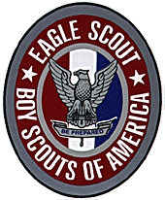

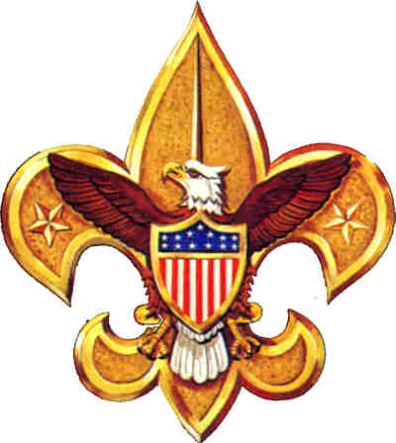

**Eagle Scout Badge Requirements**

1. Be active in your troop for a period of at least six months after you have achieved the rank of Life Scout.
2. Demonstrate that you live by the principles of the Scout Oath and Scout Law in your daily life
3. Earn a total of 21 merit badges including the following:
   1. [First Aid](http://www.scouting.org/boyscouts/advancementandawards/meritbadges/mb-FIRS.aspx)
   2. [Citizenship in the Community](http://www.scouting.org/boyscouts/advancementandawards/meritbadges/mb-CITC.aspx)
   3. [Citizenship in the Nation](http://www.scouting.org/boyscouts/advancementandawards/meritbadges/mb-CITN.aspx)
   4. [Citizenship in the World](http://www.scouting.org/boyscouts/advancementandawards/meritbadges/mb-CITW.aspx)
   5. [Communication](http://www.scouting.org/boyscouts/advancementandawards/meritbadges/mb-COMM.aspx)
   6. [Cooking](http://www.scouting.org/boyscouts/advancementandawards/meritbadges/mb-COOK.aspx)
   7. [Personal Fitness](http://www.scouting.org/boyscouts/advancementandawards/meritbadges/mb-PERF.aspx)
   8. [Emergency Preparedness](http://www.scouting.org/boyscouts/advancementandawards/meritbadges/mb-EMER.aspx) OR [Lifesaving](http://www.scouting.org/boyscouts/advancementandawards/meritbadges/mb-LIFE.aspx)
   9. [Environmental Science](http://www.scouting.org/boyscouts/advancementandawards/meritbadges/mb-ENVS.aspx) OR [Sustainability](http://www.scouting.org/scoutsource/BoyScouts/AdvancementandAwards/MeritBadges/mb-SUST.aspx)
   10. [Personal Management](http://www.scouting.org/boyscouts/advancementandawards/meritbadges/mb-PERM.aspx)
   11. [Swimming](http://www.scouting.org/boyscouts/advancementandawards/meritbadges/mb-SWIM.aspx) OR [Hiking](http://www.scouting.org/boyscouts/advancementandawards/meritbadges/mb-HIKE.aspx) OR [Cycling](http://www.scouting.org/boyscouts/advancementandawards/meritbadges/mb-CYCL.aspx)
   12. [Camping](http://www.scouting.org/boyscouts/advancementandawards/meritbadges/mb-CAMP.aspx)
   13. [Family Life](http://www.scouting.org/boyscouts/advancementandawards/meritbadges/mb-FAML.aspx)
4. While a Life Scout, serve actively in your unit for a period of six months a position of responsibility.
5. While a Life Scout, plan, develop, and give leadership to others in a service project helpful to any religious institution, any school, or your community.
6. Take part in a unit leader conference.
7. Successfully complete an Eagle Scout board of review.

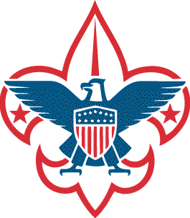

**Evan J. Murphy**

**Positions of Responsibility**

Assistant Patrol Leader, Patrol Leader, Librarian, Assistant Senior Patrol Leader, Senior Patrol Leader

**22 Elective Merit Badges Earned**

Archery, Art, Astronomy, Basketry, Bird Study, Computers, Crime Prevention, Electronics, Fingerprinting, Fish & Wildlife, Genealogy, Geology, Indian Lore, Mammal Study, Pioneering, Rifle Shooting, Shotgun Shooting, Soil & Water, Space Exploration, Tracking, Weather, & Wood Carving

**High Adventures**

Isle Royale, Philmont Scout Ranch, Sea Base Out Island Adventure, Pictured Rocks

**Special Recognitions & Awards**

Snorkeling BSA, World Conservation Award, Order of the Arrow

**Eagle Scout Project**

Evan chose St. Dominic’s Outreach Center in Detroit for his project through his school, University of Detroit Jesuit High School. U of D is a supporter of the center which provides food, clothing, and other necessities to the disadvantaged. The Center requested help in remodeling their reception area and refinishing their entrance. Evan led a team that powerwashed and resealed the entrance ramp and steps and added non-skid strips. In addition, they repainted the reception room, added new curtains and a light fixture, and a television to entertain the waiting patrons. With nearly $400 raised, the team was able to complete the project after 105 man hours of work.

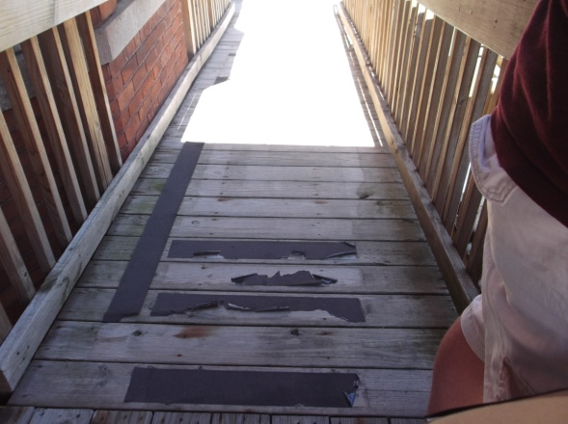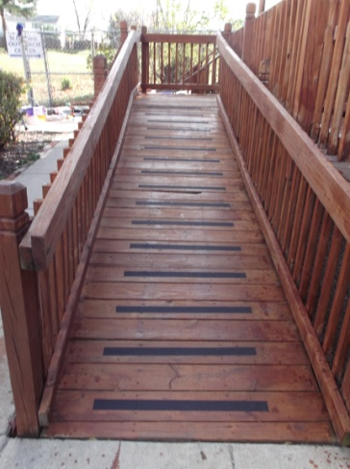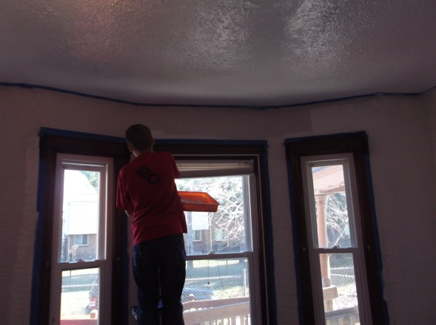

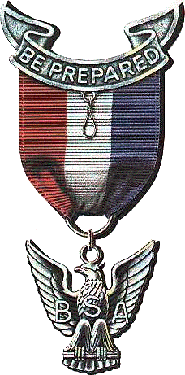

**Boy Scout Oath**

**On my honor, I will do my best**

**To do my duty to God and my country and to obey the Scout Law;**

**To help other people at all times**

**To keep myself physically strong, mentally awake and morally straight.**

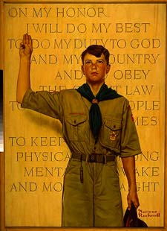

Trustworthy

Loyal

Helpful

Friendly

Courteous

Kind

Obedient

Cheerful

Thrifty

Brave

Clean

Reverent

**Troop 110 Eagle Honor Roll**

06/09/66 Mahoney, Timothy 05/07/91 Bouchard, Andrew

03/09/67 Spronz, William 09/01/92 Koshowsky, Kevin

05/04/67 Dielenhien, Michae 05/05/93 Herrmann, Peter

05/04/67 Wiedman, Timothy 05/05/93 Nagrant, Andrew

05/09/67 Hebler, Carl 05/05/93 Stoecklin, Timothy

05/09/67 Schafer, Michael 12/14/93 Luke, Jason

02/07/68 Baker, James 12/14/93 Plezia, Michael

06/11/69 Letourneau, Richard 12/03/94 Francis, Christopher

06/11/69 Rieter, Jeffrey 12/03/94 Nagrant, George

06/11/69 Spronz, Timothy 06/30/95 Evangelista, David

06/11/69 Wamby, William 11/27/97 Nuar, Nick

09/24/69 Brauer, Robert 02/01/98 Brady Jr., Michael

09/24/69 Brodie, Carl 08/24/98 Ehrlich, David

10/08/69 Mahoney, Thomas 08/24/98 Hinbern, Carl

05/27/70 Semposki, Edwin 11/11/98 Brincat Jr., Joe

11/07/70 Trout, Theodore 05/09/01 Hinbern, Billy

11/11/70 Dielenhein, Steven 05/09/01 White, Mike

03/31/71 Brennan, Michael 12/12/01 Doughty, Brian

03/31/71 Hanes, Jeffrey 01/13/02 Smith, Alex

10/20/71 Hebler, Paul 03/05/02 Ehrlich, Matt

05/31/72 Gorman, Robert 03/05/02 Work, Collin

12/12/72, Kelly, Martin 02/06/03 Gronbach, Jay

06/05/73 Bonfiglio, Michael 06/18/03 Schallmo, Michael

06/05/73 Carrier, Timothy 03/17/04 Boese, Gordon

06/05/73 Hansen, Joseph 06/07/04 Kritman, Jeffrey

06/05/73 Lilley, Rick 09/20/04 Reynolds, Thomas

12/18/73 Carrier, Thomas 11/21/04 Maki, Thomas

12/18/73 Good, David 05/11/05 Henri, Ross

12/18/73 Hansen, Peter 09/25/05 Joshua D. Roma

05/03/75 Chuba, Peter 12/05/05 Ried, Ryan

12/16/75 Granning, Kristoffer 02/22/06 Holtzman, Emmett P.

05/24/78 Crane, Stephen 06/13/06 Nagrant, Michael

05/24/78 Hart, Thomas 10/03/06 Ellis, Samuel

05/15/80 Joppich, Daniel 10/03/06 Ostin, Drew

05/15/80 Rosowski, John 10/19/06 Dwyer, Andrew J.

11/11/80 Howie, Dennis 02/12/07 Vallender, Joshua (Crew)

05/05/81 Benoit, Michael 02/20/07 Boucher, Matthew

05/05/81 Konitsney, James 02/11/08 Schumacher, Andrew

05/05/81 Telliner, David 02/25/08 Hirsch, Matthew

05/10/82 Granning, David 10/02/08 Laskosky, Bradley

05/10/82 Hansen, James 03/09/09 Johnston, Sean P.

05/10/82 Stevenson, David 03/29/09 Kidd, Garett

12/06/82 Singer, Daniel 07/01/09 Koziara, Brian

05/09/83 Macdonald, Tim 09/15/09 Bedard, Daniel

12/12/83 Howie, Jeffrey 10/25/09 Hebden, James

05/07/84 Good, Christopher 02/22/10 Terzich, Zachary S.

05/07/84 Surowiec, Gerald 12/16/10 Schumacher, Timothy W.

05/07/84 Surowiec, James 04/06/11 Boucher, Jayson A.

12/03/84 Plezia, Gregory 05/02/11 Smith, Michael R.

05/10/86 Herrmann, Kenneth 06/14/11 Salzwedel, Mark

05/10/86 Stillwagon, Patrick 01/19/12 Terzich, Samuel M.

12/15/86 Nagrant, Nicholas 05/09/12 Wagoner, Lee W.

01/14/87 Mcgowan, Patrick 06/12/12 Green, James

02/26/87 Herrmann, Michael 07/18/12 Lindenmuth, Connor

05/15/87 Hansen, George 04/09/13 Green, David R.

05/05/88 Martin, Thomas 06/18/13 Hirsch, Jonathan

05/20/09 Bouchard, Jonathan 06/18/13 Williams, Nate S.

05/02/90 Cavagnol, Robert 11/07/13 Murphy, Evan J.